LAB 2 - PROGRAM 1
#include <stdio.h>

struct Process {
int pid;
int at;
int bt;
int wt;
int tat;
int completed;
};

int main() {
int n, time = 0, completed = 0;
int sum_wt = 0, sum_tat = 0;
struct Process p[20];

printf("Enter number of processes: ");
scanf("%d", &n);

// Input section
for(int i = 0; i < n; i++) {
p[i].pid = i + 1;

printf("Enter Arrival Time for Process %d: ", i+1);
scanf("%d", &p[i].at);

printf("Enter Burst Time for Process %d: ", i+1);
scanf("%d", &p[i].bt);

p[i].completed = 0;
}

while(completed < n) {
int idx = -1;
int min_bt = 9999;

for(int i = 0; i < n; i++) {
if(p[i].at <= time && p[i].completed == 0) {
if(p[i].bt < min_bt) {
min_bt = p[i].bt;
idx = i;
}
}
}

if(idx != -1) {
time += p[idx].bt;

p[idx].tat = time - p[idx].at;
p[idx].wt = p[idx].tat - p[idx].bt;

sum_wt += p[idx].wt;
sum_tat += p[idx].tat;

p[idx].completed = 1;
completed++;
}
else {
time++;
}
}

printf("\nProcess\tAT\tBT\tWT\tTAT\n");
for(int i = 0; i < n; i++) {
printf("P%d\t%d\t%d\t%d\t%d\n",
p[i].pid, p[i].at, p[i].bt, p[i].wt, p[i].tat);
}

printf("\nAverage Waiting Time: %.2f", (float)sum_wt/n);
printf("\nAverage Turnaround Time: %.2f", (float)sum_tat/n);

return 0;
}
OUTPUT :
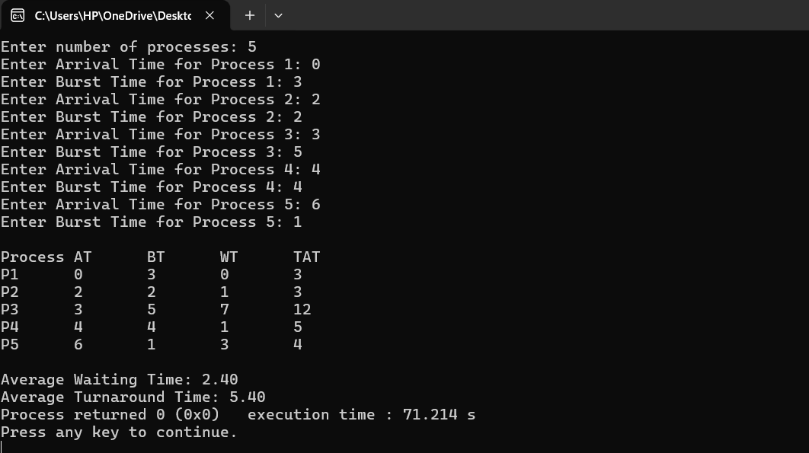

PROGRAM – 2 :
#include <stdio.h>

struct Process {
int pid;
int at;
int bt;
int rt;
int wt;
int tat;
};

int main() {
struct Process p[20];
int n, time = 0, completed = 0;
int min_rt, smallest = -1;
int finish_time;
int sum_wt = 0, sum_tat = 0;

printf("Enter number of processes: ");
scanf("%d", &n);

for(int i = 0; i < n; i++) {
p[i].pid = i + 1;

printf("Enter Arrival Time for Process %d: ", i+1);
scanf("%d", &p[i].at);

printf("Enter Burst Time for Process %d: ", i+1);
scanf("%d", &p[i].bt);

p[i].rt = p[i].bt;
}

while(completed != n) {
min_rt = 9999;
smallest = -1;

for(int i = 0; i < n; i++) {
if(p[i].at <= time && p[i].rt > 0 && p[i].rt < min_rt) {
min_rt = p[i].rt;
smallest = i;
}
}

if(smallest == -1) {
time++;
continue;
}

p[smallest].rt--;
time++;

if(p[smallest].rt == 0) {
completed++;
finish_time = time;

p[smallest].tat = finish_time - p[smallest].at;
p[smallest].wt = p[smallest].tat - p[smallest].bt;

if(p[smallest].wt < 0)
p[smallest].wt = 0;

sum_wt += p[smallest].wt;
sum_tat += p[smallest].tat;
}
}

printf("\nProcess\tAT\tBT\tWT\tTAT\n");
for(int i = 0; i < n; i++) {
printf("P%d\t%d\t%d\t%d\t%d\n",
p[i].pid, p[i].at, p[i].bt, p[i].wt, p[i].tat);
}

printf("\nAverage Waiting Time: %.2f", (float)sum_wt/n);
printf("\nAverage Turnaround Time: %.2f", (float)sum_tat/n);

return 0;
}

OUTPUT :
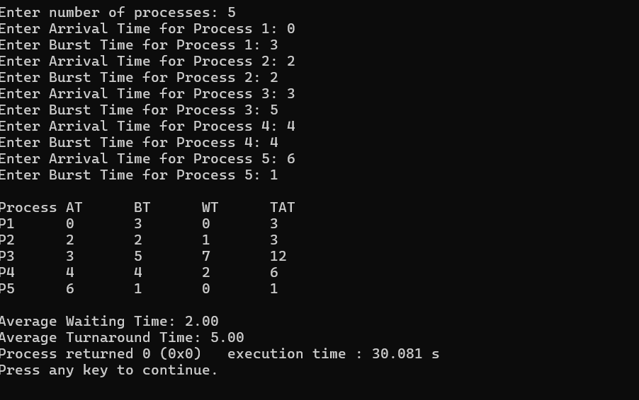

PROGRAM - 3 :

#include <stdio.h>

struct process {
int pid;
int at;
int bt;
int pr;
int wt;
int tat;
};

int main() {
int n, i, j;
struct process p[20], temp;

printf("Enter number of processes: ");
scanf("%d", &n);

for(i = 0; i < n; i++) {
p[i].pid = i + 1;

printf("\nProcess %d\n", i + 1);

printf("Enter Arrival Time: ");
scanf("%d", &p[i].at);

printf("Enter Burst Time: ");
scanf("%d", &p[i].bt);

printf("Enter Priority: ");
scanf("%d", &p[i].pr);
}

for(i = 0; i < n - 1; i++) {
for(j = i + 1; j < n; j++) {
if(p[i].at > p[j].at) {
temp = p[i];
p[i] = p[j];
p[j] = temp;
}
}
}

int time = 0;
int completed = 0;
int visited[20] = {0};

while(completed < n) {
int idx = -1;
int highest = 999;

for(i = 0; i < n; i++) {
if(p[i].at <= time && visited[i] == 0) {
if(p[i].pr < highest) {
highest = p[i].pr;
idx = i;
}
}
}

if(idx != -1) {
p[idx].wt = time - p[idx].at;
time += p[idx].bt;
p[idx].tat = p[idx].wt + p[idx].bt;

visited[idx] = 1;
completed++;
}
else {
time++;
}
}

printf("\nProcess\tAT\tBT\tPR\tWT\tTAT\n");

for(i = 0; i < n; i++) {
printf("P%d\t%d\t%d\t%d\t%d\t%d\n",
p[i].pid, p[i].at, p[i].bt,
p[i].pr, p[i].wt, p[i].tat);
}

return 0;
}

OUTPUT :
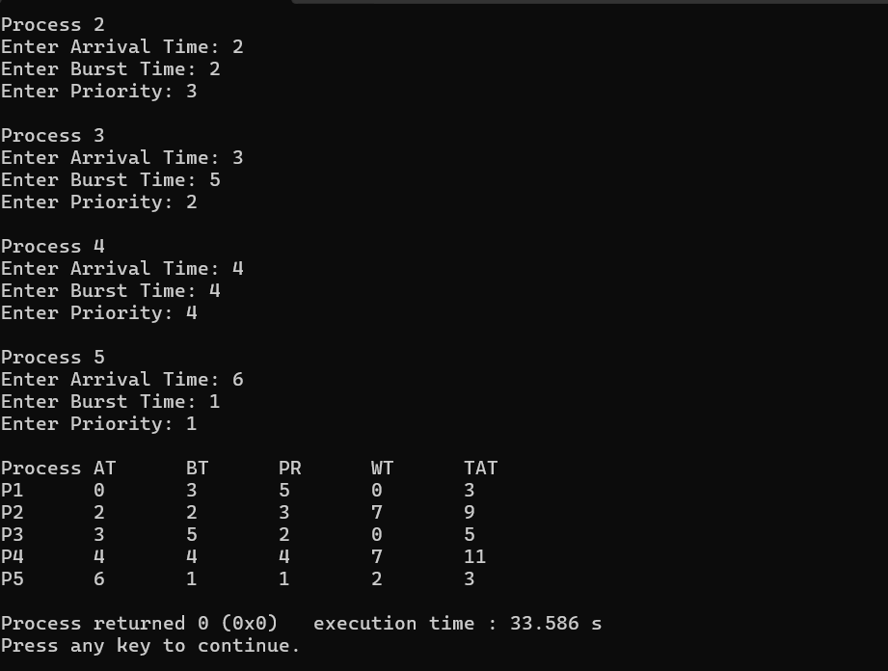

PROGRAM – 4 :
include <stdio.h>

struct process {
int pid;
int at;
int bt;
int rt;
int pr;
int wt;
int tat;
};

int main() {
struct process p[20];
int n, i;
int time = 0, completed = 0;
int highest, finish_time;
float avg_wt = 0, avg_tat = 0;

printf("Enter number of processes: ");
scanf("%d", &n);

for(i = 0; i < n; i++) {
p[i].pid = i + 1;

printf("\nProcess %d\n", i+1);

printf("Enter Arrival Time: ");
scanf("%d", &p[i].at);

printf("Enter Burst Time: ");
scanf("%d", &p[i].bt);

printf("Enter Priority: ");
scanf("%d", &p[i].pr);

p[i].rt = p[i].bt;
}

while(completed != n) {
highest = -1;

for(i = 0; i < n; i++) {
if(p[i].at <= time && p[i].rt > 0) {
if(highest == -1 || p[i].pr < p[highest].pr) {
highest = i;
}
}
}

if(highest == -1) {
time++;
continue;
}

p[highest].rt--;
time++;

if(p[highest].rt == 0) {
completed++;
finish_time = time;

p[highest].wt = finish_time - p[highest].bt - p[highest].at;
if(p[highest].wt < 0)
p[highest].wt = 0;
}
}

for(i = 0; i < n; i++) {
p[i].tat = p[i].bt + p[i].wt;

avg_wt += p[i].wt;
avg_tat += p[i].tat;
}

avg_wt /= n;
avg_tat /= n;

printf("\nProcess\tAT\tBT\tPR\tWT\tTAT\n");

for(i = 0; i < n; i++) {
printf("P%d\t%d\t%d\t%d\t%d\t%d\n",
p[i].pid, p[i].at, p[i].bt, p[i].pr, p[i].wt, p[i].tat);
}

printf("\nAverage Waiting Time = %.2f", avg_wt);
printf("\nAverage Turnaround Time = %.2f\n", avg_tat);

return 0;
}

OUTPUT :
